**Nile University**

**Software Requirement Specification**

CSCI 313 – software Engineering

**Project name:** store-tech

**Project Type:** Android App and Website

By:

Hussein El-Shazly Eida

Salma Khaled Hegazy

Darwish Mohmed Darwish

Ghada Ali Sallam

Amr Mohmed Abo El-Souad

Abd El-Rahman El-Gebaly

Table of Contents

**1.** **Introduction** 4

1.1 Purpose 4

1.2 Scope 4

1.3 Definitions, Acronyms, and Abbreviations 4

1.4 Technologies uses 5

1.4.1 Website 5

1.4.2 Mobile Application 5

1.5 Intended audience 6

1.6 Overview 6

**2.** **Overall Description** 7

2.1 Product Perspective 7

**3.** **Interface** 8

3.1 System interface 8

3.2 Software Interface 10

3.3 Hardware Interface 10

**4.** **Specific requirement** 11

4.1 functional requirement 11

4.1.1 Module1: Login 11

4.1.2 Module2: add item 11

4.1.3 Module3: delete item 11

4.1.4 Module4: view item 11

4.1.5 module5: sign up 11

4.1.6 Module6: delete from cart 11

4.1.7 Module7: view cart 11

4.1.8 Module8: search item 12

4.1.9 Module9: view total amount 12

4.1.10 Module10: checkout 12

4.1.11 Module11: Cancel order 12

4.2 Non-Functional Requirement 13

**5.** **Use Case Diagram** 14

**6.** **Sequence Diagram** 15

6.1 Login 16

6.2 Add Item 17

6.3 Delete Item 18

6.4 View Item 19

6.5 Sign up 20

6.6 Delete from cart 21

6.7 View cart 22

6.8 Search Item 23

6.9 checkout 24

**7.** **Class Diagram** 25

**8.** **Sprint Retrospective** 26

# **Introduction**

This document presents a detailed description of the STORE-TECH(Android Application and Website) which is to be used by the faculty, staff and students to get the description of each categories and to know the trending item to be bought.

## Purpose

The purpose of the software Requirement Specification (SRS) is to specify the functionality, performance, and interface requirements of software project. All the required features of the software project expressed by the client and agreed upon by the development team shall be expressed in this document. Additional requirement of the client shall first be agreed upon by the developed team. The formal release version of the project shall meet every requirement listed in this document.

## Scope

The Store-tech is a website and mobile app. The application offers various tech categories, such as Laptops, mobile phones, Mobile Accessories, Memory Card, Tablets, Spare parts (chargers, screens keyboard), Cameras, Smart watches, Cables, Headsets, Speakers, Security Cameras, Home Telephone, and UPS. This service is conveniently grouped and developed specifically for use on the android. All the categories can be offered when an internet connection is available.

## Definitions, Acronyms, and Abbreviations

Android: developed by google, a poplar operating system for smart phones.

CPU: Central Processing Unit. It is a hardware device in a computer that is responsible for most (if not all) of the mathematical calculations required by the computer. All program execution is performed by the CPU. The CPU includes all derived components including the ALU (arithmetic logic unit), cache and registers.

GUI: Graphical User Interface. An interface that receives and reacts to the user input with a graphical display.

Disk Storage: May be any storage medium mapped to the root file system.

Store-tech: the android application being developed.

HTML: Hypertext Markup Language. In the context of this document it is assumed to refer to HTML version 4.01 as defined by the World Wide Web Consortium. HTML output reports generated by El Monte Carlo shall use the Transitional DTD, as defined by W3C.

IDE: Integrated Development Environment is a tool to aid programmers in writing code, usually used for graphical applications.

SRS: Software Requirements Specification.

Windows: Developed by Microsoft, the most widely used operating system for desktop computers.

RAM: Volatile memory used by the CPU for storing data too large to fit in a register along with execution code of the running programs.

JS: java script is a programming language commonly used in web development. It was originally developed by Netscape to add dynamic and interactive elements to websites.JavaScript code can be inserted anywhere within the HTML of a webpage.

Laravel: is a web application framework with expressive, elegant syntax. We have already laid the foundation — freeing you to create without sweating the small things.

Firebase: is Google's mobile platform that helps you quickly develop high-quality apps and grow your business.

Flutter: is Google's UI toolkit for crafting beautiful, natively compiled applications for mobile, web, and desktop from a single codebase.

API: is the acronym for Application Programming Interface, which is a software intermediary that allows two applications to talk to each other.

Dart:is a client-optimized language for fast apps on any platform.

## Technologies uses

### Website

* Html
* CSS
* JS
* PHP
* Laravel
* MySQL
* firebase

### Mobile Application

* Dart
* Flutter
* Firebase
* API

## Intended audience

This document is useful to: -

Customer: To follow up with the project team if there are requirements change.

Developer: To have ease of implementation. Software Tester: To be able to develop the correct test cases for the system and test it to improve the system's quality. Software architect: To be able to design and improve the system's architecture.

Project Manager/SCRUM Master: To be able to develop a good plan to work on the project and construct the team.

## Overview

This chapter explain the categories would be offered in the application and website Store-tech. how it can help the university. It shows also the techniques would be used to build this software. The rest of the SRS will explain the detailed specifications of the application.

# **Overall Description**

## Product Perspective

* ” E-Tech” is an E-commerce mobile app and website that make you can find the best products of your desire in electronic devices; Users can choose his favorite products and buy it online through mobile app or website.
* System has multiple categories such as (Mobiles, Laptops, Desktops, Microphone, etc........)
* The System uses the centralized database which contains all the information. It works on any android phone or through any browser for website.

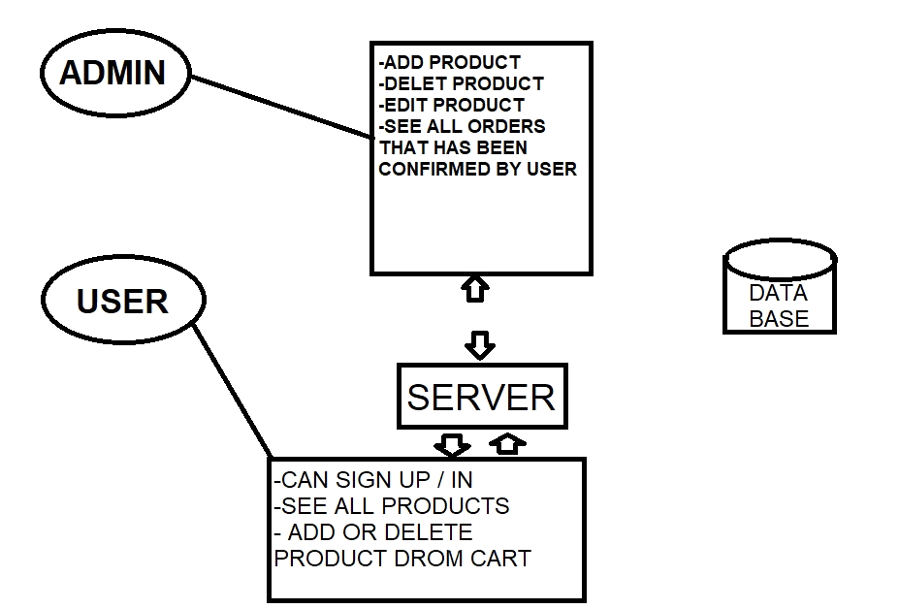

Simple Block Diagram for "E-Tech" Application

# **Interface**

## System interface

* First time that user use app or website he/she would see the login page if he not signed up, he would need to sign up to have an account that allow him to log in to the app and then see the homepage of products as figures seen below**.**

The home page contains search bar allow you to search for specific product and categories to view page has a lot of products attached to your selection topic.

* If the user selects any product, he will go to product details screen and he can add the product to cart if he wants to buy it.
* When he finishes, he will go to page that verify his operation to buy all product in cart.

## Software Interface

* E-Tech app is a Mobile app and Website will be developed for android operating systems environment and Browsers environment Using Dart language and Flutter framework and Android SDK tools and Flutter packages are used all of this for app.
* For website (Html, CSS, Java script, PHP, Laravel framework)
* System shall communicate with to run data queries. System shall use Laravel framework to handle database between android application and Website using API.

## 3.3 Hardware Interface

E-Tech app is in need to mobile devise or desktop that allow the app or website use internet and Access to data.

Communication between server and application needs network with based on HTTP and HTTPS protocols

""Project doesn’t include payment methods.

# **Specific requirement**

## functional requirement

### Module1: Login

AIM: Admin and user can login to get access to the product with the help of unique login-username & password.

INPUT: username & password

OUTPUT: Displays a message if username and password does not match otherwise enter the home page.

PROCESS: Match username and password from the database.

### Module2: add item

AIM: to add an item.

INPUT: item name & department

OUTPUT: item added successfully.

PROCESS: save all the data in the database.

### Module3: delete item

AIM: to delete an item.

INPUT: item name& department.

OUTPUT: item deleted successfully.

PROCESS: to updating data in the database.

### Module4: view item

AIM: To view item details by their department.

INPUT: Department name.

OUTPUT: The detailed of required items.

PROCESS: To retrieved data from item table in the database.

### module5: sign up

AIM: To add new account.

INPUT: name, email, location, phone& password.

OUTPUT: Registered successfully.

PROCESS: To save new authenticated user in our database.

### Module6: delete from cart

AIM: To delete item from cart.

INPUT: Item name

OUTPUT: Deleted successfully.

PROCESS: To update data in the database.

### Module7: view cart

AIM: To view item in cart

INPUT: selected items.

OUTPUT: the detailed of required products

PROCESS: To retrieved data from item table in the database.

### Module8: search item

AIM: To search an item

INPUT: Item name& department

OUTPUT: The detailed of required item.

PROCESS: To retrieved data from item table in the database.

### Module9: view total amount

AIM: view the total amount of fees in chart.

INPUT: selected item.

OUTPUT: Detailed amount of fees.

PROCESS: To collect all fees in cart from our database.

### Module10: checkout

AIM: To check out the selected products.

INPUT: Credit card, PIN.

OUTPUT: Payment and checkout successfully.

PROCESS: To update selected item in the database.

### Module11: Cancel order

AIM: To cancel order.

INPUT: order id.

OUTPUT: order canceled successfully.

PROCESS: To update order table in the database.

## Non-Functional Requirement

Reliability:

The mean time between failures should be at Max 2 times per year.

Security:

Security requirements placed restrictions on the use of this application by customers of Wireless Lan communicator only, control access to the data, provide different kinds of requirements to different people, require the use of passwords. It requires proper programming techniques.

Maintainability:

Maintenance is one form of change that typically is done after the software development has been completed. As the time change, so do the needs. It revolves around the understanding of the existing s/w and the effects of the change. This application needs a timely updating of information table of the database by the admin. Any other feature as per the requirement can be

added any time by the admin.

Portability:

The capability adapted for different specified environments without applying actions or means other than those provided for this purpose in the product. Since, phones are portable, so do the application.

Performance:

Loading pages in Store-Tech should not exceed 2 seconds (Response time).

Availability:

System should be able to run for 24 hours a day and 7 days a week.

# **Use Case Diagram**

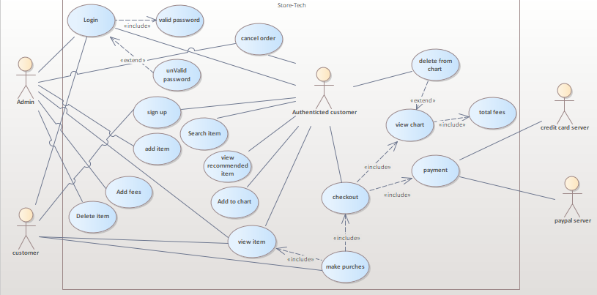

# **Sequence Diagram**

## Login

## Add Item

## Delete Item

## View Item

## Sign up

## Delete from cart

## View cart

## Search Item

## checkout

# **Class Diagram**

# **Sprint Retrospective**

